Day 11 Blackjack Program

Deal , hit , stand winner closest to 21 without over

2-10

Royalty 10

Ace 1 or 11

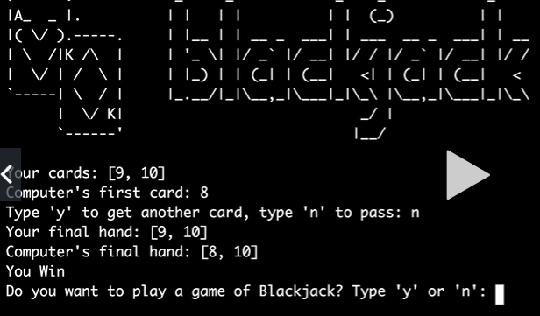

My flow

